**“** ONLINE BANQUET MANAGEMENT SYSTEM **“**

A project report submitted in partial fulfillment of requirement for the award of the degree of

### BACHELOR OF COMPUTER APPLICATIONS



**RANI CHANNAMMA UNIVERSITY, BELAGAVI.**

### Submitted by:

### MR CHAITANYA. D. PATIL

### MR SANKET. N. BHOGAN

### 

### Under the guidance of

### Prof. Prakash Deshpande

### Prof. Vaishali Shanbhag



**Karnatak Law Society’s**

**GOGTE COLLEGE OF COMMERCE TILAKWADI BELGAVI -590006**

**2022-2023**

**Karnatak Law Society’s**

**GOGTE COLLEGE OF COMMERCE**

**Tilakwadi, Belgaum-590006**

**Bachelor of Computer Applications**



**CERTIFICATE**

**This is to certify that** Mr. Chaitanya. D. Patil **Reg No.** M2010840has satisfactorily completed the project work entitled“ONLINE BANQUET MANAGEMENT SYSTEM**”** for the fulfillment of **Bachelor’s Of Computer Applications of Rani Channamma University, Belgaum,** for the year

2022-2023.

**Guide**

**Prof. Prakash Deshpande**

**Principal**

**Dr. H. H. Veerapur**

**Coordinator**

**Prof. V. S. Jalihal**

EXAMINERS

1. 2.

**Dedicated**

**to Teachers**

**And Friends.**

**ACKNOWLEGEMENT**

**ACKNOWLEDGEMENT**

“A helping hand, and kind soul are the ingredients that helps us to make a success out of any efforts.”

We have taken efforts in this project. However, it would not have been possible without the kind support and help of many Faculties. We would like to extend my sincere thanks to all of them.

We take this opportunity to acknowledge the contribution of each individual who has in some way or other helped me in completing this project successfully. We express our gratitude to our institute, **Karnataka Law Society’s Gogte College Of Commerce (BCA Dept),** **Belgaum** and our **Principal Dr. H. H. Veerapur** for being the source of encouragement.

We also enhance our gratitude to our beloved **Prof Venugopal Jalihal, Co-ordinator BCA Dept** for his constant inspiration and for providing necessary resources and working environment in this college.

With pleasure, we use this occasion to concede our heartfelt thanks to **Prof. Prakash Deshpande** our internal guide who has guided us with her valuable suggestion & guidance.

Our expressions extends unbounded to thank our most beloved parent and family members who have always been a moral support and strong pillars at every stage of our life with cheer enthusiasm. We dedicate our work to them.

Last but not the least, we are thankful to Almighty’s moral support, which helped us during successful completion of the project.

With heartfelt thanks to One & All,

**Chaitanya. D. Patil and Sanket. N. Bhogan**

|  |  |  |
| --- | --- | --- |
| **SL.NO** | **TOPIC** | **PAGE** |
| 1. | Synopsis of the project |  |
| 2. | Introduction to area  Project Description |  |
| 3. | Objective and scope of the project |  |
| 4. | System Study |  |
| 5. | System Study |  |
| 6. | Project Planning And Scheduling   1. Pert Chart 2. Gantt Chart |  |
| 7. | Methodology adopted |  |
| 8. | System Specification |  |
| 9. | Detailed Life Cycle of the Project   1. Data Flow Diagram(DFD) 2. Use Case Diagram 3. Entity Relationship Diagram1(ER) 4. Activity Diagram |  |
| 10. | Database Design |  |
| 11. | Coding |  |
| 12. | Input and Output Screen Design |  |
| 13. | Testing |  |
| 14. | Conclusion |  |
| 15. | Future Enhancement |  |

**INDEX**

**1.**

**Synopsis**

**PROJECT SYNOPSIS**

The aim of ‘Online Banquet Management System’ is to automate its existing manual system by the help of computerized equipment and full-fledge computer software, fulfilling their requirements so that their valuable date can be stored for a longer period with easy accessing and manipulation of the same. Basically the project describes how to handle good performance and provide better services to clients. This project can lead to error free, secure, reliable and fast management system. This system will help the organization in better utilization of resources.

An event venue may be an onsite or offsite location. The event manager is responsible for operations at a rented event or entertainment venue as they are coordinating directly with the property owner. An event manager will monitor all aspects of the event on-site. Some of the tasks listed in the introduction may pass to the venue, but usually it will cost a lot.

Banquet Management System is the application of project management to the creation and development of small and/or large-scale personal or corporate events such as festivals, conferences, ceremonies, weddings, formal parties, concerts, or conventions.

**OBJECTIVES:**

* The objective of this project is to provide an interface where it helps the customer to analyse a venue for different types of ceremony’s anywhere anytime.
* The venue’s which are registered here are around Belgaum location and it tells that it is available at that time or no.
* It is user friendly interface where it can provide easy options to and for the customer.
* It provides an interface where it allows user to search any venue based on there requirements and can compare the cost with the other one’s.
* Flexible hours

**MODULES:**

1. **ADMIN MODULE :**

* Admin need to enter his Username and Password.
* Once the user sends his request the admin can view details and according to users can book a venue.
* Admin can also update his profile, change the password and recover the password.
* The Admin has an option to except or reject the user’s request.
* Admin can add new venue whenever required.
* Admin can take an action for any query request of user.

1. **USER MODULE :-**

* A new user can register and an existing user can login / logout whenever required.
* A user can update his profile when required.
* A user can send a booking request to the admin and can get confirmed if the venue is available or no.
* User can select any type of event / ceremony while booking.
* User can mail the admin for any query.

**HARDWARE REQUIREMENTS :-**

* Hard disc : 4 GB min
* Operating System : Windows 7 or Above.
* Processor : Dual Core or Above.
* Processor speed : 1.5 GHz
* Internet Availability : Wifi , Ethernet etc.

**SOFTWARE REQUIREMENTS :-**

* Frontend Language : Html, JQuery, JavaScript
* Backend Language : PHP
* Web Browser : Any
* Database : MySQL
* Server : XAMP

**USER REQUREMENTS:**

**FUNCTIONAL REQUIREMENT**

Functional requirement defines a function of a software system or its component. A function is described as a set of inputs, the behaviour, and outputs. Functional requirements may be calculations, technical details, data manipulation and processing and other specific functionality that define what a system is supposed to accomplish. Behavioural requirements describing all the cases where the system uses the functional requirements are captured in use cases.

**NON FUNCTIONAL REQUIREMENT**

**Reliability:**

In this system reliability means the mail which is send by the source must reach the target user with any modification and accurate.

**Security:**

The web server and database server should be protected from hacking, virus etc

**Portability:**

The application will be developed using standard open source software like PHP, Apcahe web server, MySQL database, Internet Explorer Browser etc these software will work both on Windows and Linux o/s. Hence portability problems will not arise.

**Availability:**

This software will be available always.

**Maintainability:**

In this system the presentation layer is clearly separated from the service layer. So any modification in future will be done with less effort. The database will be running at the server. Users access these forms by using the user-ids and the passwords.

**2.**

**Introduction**

**Introduction**

The objective of this application is to develop a system that effectively manages all the data related to the various banquet booking events that take place at the venue. The purpose is to maintain a centralized database of all banquet event related information. The goal is to support various functions and processes necessary to manage the data efficiently.

The aim of ‘Online Banquet Management System’ is to automate its existing manual system by the help of computerized equipment and full-fledge computer software, fulfilling their requirements so that their valuable date can be stored for a longer period with easy accessing and manipulation of the same. Basically the project describes how to handle good performance and provide better services to clients. This project can lead to error free, secure, reliable and fast management system. This system will help the organization in better utilization of resources.

An event venue may be an onsite or offsite location. The event manager is responsible for operations at a rented event or entertainment venue as they are coordinating directly with the property owner. An event manager will monitor all aspects of the event on-site. Some of the tasks listed in the introduction may pass to the venue, but usually it will cost a lot

**Existing System**

This existing system is not providing secure registration and profile management of all the users properly. This system is not providing on-line Help. This system doesn’t provide tracking of users activities and their progress. This manual system gives us very less security for saving data and some data may be lost due to mismanagement. This system is not providing event management through internet. This system is not providing proper events information. The system is giving manual information through the event management executer.

**Proposed System**

The development of this new system contains the following activities, which try to automate the entire process keeping in the view of database integration approach. This system maintains user’s personal, and contact details. This system will provide on line help and search capabilities. User friendliness is provided in the application with various controls provided by system rich user interface. Authentication is provided for this application only registered users can access. Banquet event information files can be stored in centralized database which can be maintained by the system. This system provides the users to manage the banquet events systematically.

**3.**

**OBJECTIVES**

**AND**

**SCOPE OF**

**PROJECT**

**OBJECTIVES:**

* The objective of this project is to provide an interface where it helps the customer to analyze a venue for different types of ceremony’s anywhere anytime.
* The venue’s which are registered here are around Belgaum location and it tells that it is available at that time or no.
* It is user friendly interface where it can provide easy options to and for the customer.
* It provides an interface where it allows user to search any venue based on there requirements and can compare the cost with the other one’s.
* Flexible hours.

**SCOPE:**

This application can be used to plan a perfect ceremony with a perfect plan and celebrate it in a grand fashion.

**4.**

**SYSTEM**

**STUDY**

**REQUIREMENTS**.

1. **FEASIBILITY STUDY**

A feasibility study is a high-level capsule version of the entire System analysis and Design Process. The study begins by classifying the problem definition. Feasibility is to determine if it’s worth doing. Once an acceptance problem definition has been generated, the analyst develops a logical model of the system. A search for alternatives is analyzed carefully. There are 3 parts in feasibility study.

1. **TECHNICAL FEASIBILITY**

Does the necessary technology exist to do what is been suggested Does the proposed equipment have the technical capacity for using the new system? Are there technical guarantees of accuracy, reliability and data security? The project is developed on Pentium III with 128 MB RAM.The environment required in the development of system is any windows platform.The observer pattern along with factory pattern will update the results eventually.

The language used in the development is PHP, Apache Server and database as MySQL.

1. **ECONOMIC FEASIBILITY**

To decide whether a project is economically feasible, to consider various factors as cost benefit analysis, long-term returns and maintenance costs

1. **OPERATIONAL FEASIBILITY**

Questions that going to be asked are Will the system be used if it developed and implemented.If there was sufficient support for the project from the management and from the users.Have the users been involved in planning and development of the Project.

**DEPLOYMENT MODEL:**

* **USABILITY:**

This application is easy to use so user will not require special training.

* **PERFORMANCE:**

It provides faster way to book a banquet of a hall within a time.

* **SECURITY:**

It provides secure bookings and user information in our database.

.

* **MAINTAINABILITY:**

As the time changes, as per user’s requirements this application can be modified easily.

**6.**

**Project**

**Planning**

**And**

**Scheduling**

**PERT CHART**

**(Program Evaluation and Review Technique)**

A PERT chart is a graphic representation of a project’s schedule, showing the sequence of tasks, which tasks can be performed simultaneously, and the critical path of tasks that must be completed on time in order for the project to meet its completion deadline. The chart can be constructed with a variety of attributes, such as earliest and latest start dates for each task, earliest and latest finish dates for each task, and slack time between tasks. A PERT chart can document an entire project or a key phase of project. The chart allows a team to avoid unrealistic timetables and schedule expectations, to help identify and shorten tasks that are bottlenecks, and to focus attention on most critical tasks.

Because it is primarily a project-management tools, a PERT chart is most useful for planning and tracking entire projects or for scheduling and tracking the implementation phase of a planning or improvement effort.

**Pert Chart**

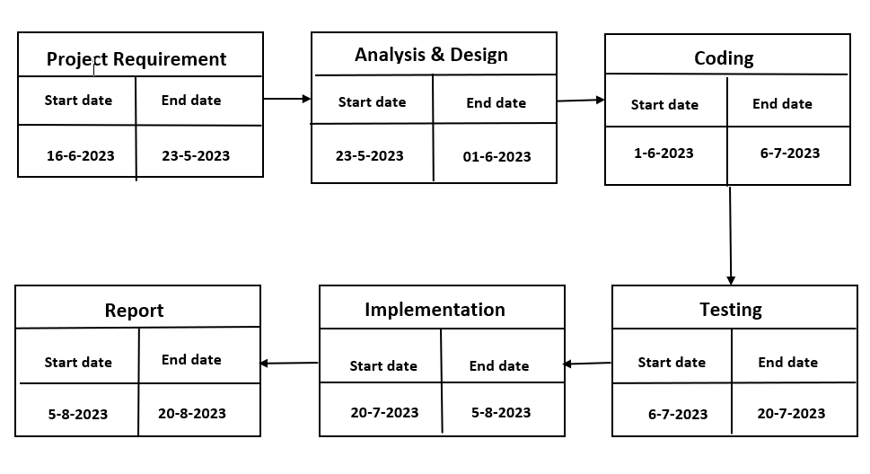

**GANTT CHART:**

A Gantt chart is a type of bar chart that illustrates a schedule. It illustrates the start and finish dates of the terminal elements and summary elements of a project.

**Gantt Chart**

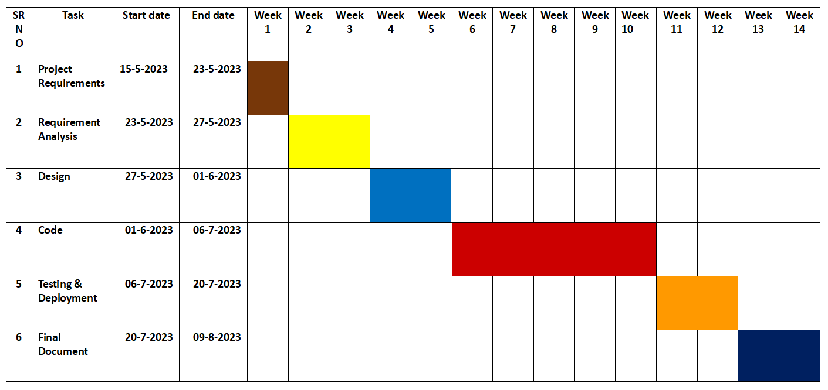

**7.**

**Methodology**

**adopted**

**WATERFALL MODEL:**

In waterfall model, we proceed from one phase to the next in a sequential manner.

Requirement analysis, design, implementation, testing, deployment and Maintenance are the different sequential phases. That is once the requirement analysis is completed perfectly we proceed towards design phase. When the design is totally completed, the implementation of that design is performed by the coders. After completing the coding. The testing phase begins. The objective of testing is to uncover errors. The next is the deployment maintenance phase.

**ADVANTAGES:**

* This model is simple and easy to understand and use.
* It is easy to manage due to the rigidity of the model.
* In this model phases are processed and completed one at a time. Phases do not overlap.
* Waterfall model works well for projects where requirements are very well understood.

**DISADVANTAGES:**

* No working software is produced until late during the life cycle.
* High amount of risk and uncertainty.
* Not good model for complex and object oriented projects.
* Poor model for long and ongoing projects.

**WATERFALL MODEL:**

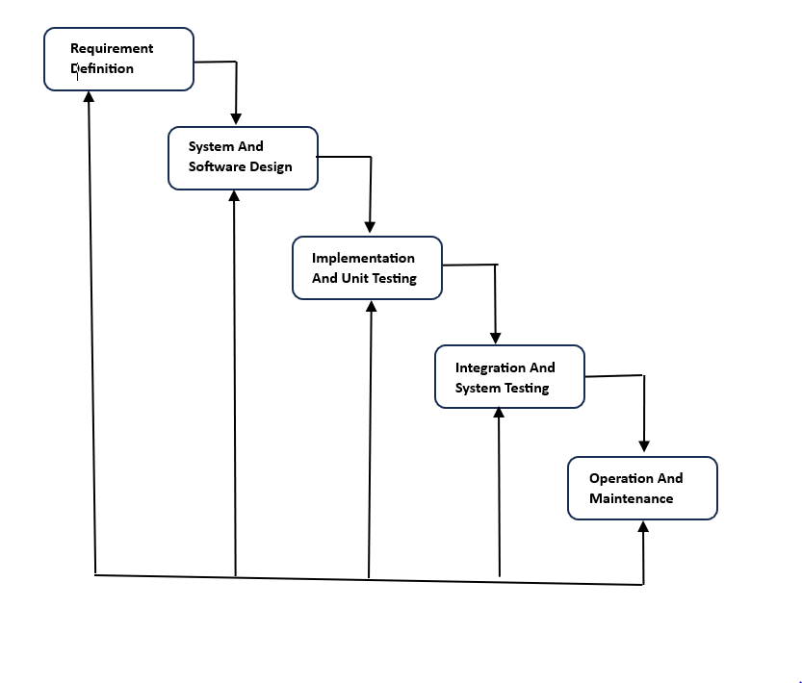

**THE PRINCIPAL STAGES ARE:**

1. **REQUIREMENT GATHERING & DEFINITION:**

The system services, constraints and goals are established by consultation with the system users. They are then defined in detail and serve as system specification.

1. **SYSTEM DESIGN:**

It establishes overall system architecture. Software design involves identifying and describing the fundamental software system abstraction and their relationships.

1. **IMPLEMENTATION & UNIT TESTING:**

Software design is realized as a set of program or program units. Unit testing involves verifying that each unit needs its specification.

1. **INTEGRATION & SYSTEM TESTING:**

The individual program units are integrated and tested as a complete system to ensure that the software requirements have been meet.

1. **OPERATION & MAINTENANCE:**

The system is installed and put into partial use. Maintenance involves correcting errors, which were not discovered into earlier stage of the life cycle and enhancing the systems as new requirements are discovered.

**8.**

**System**

**Specification**

**SYSTEM SPECIFICATION:**

**HARDWARE REQUREMENTS:**

* Hard disc : 4 GB min
* Operating System : Windows 7 or Above.
* Processor : Dual Core or Above.
* Processor speed : 1.5 GHz
* Internet Availability : Wifi , Ethernet etc

**SOFTWARE REQUIREMENTS:**

* Frontend Language : Html, JQuery, JavaScript
* Backend Language : PHP
* Web Browser : Any
* Database : MySQL
* Server : XAMP

**9.**

**Detailed**

**Life Cycle**

**Of The**

**Project**

**DATA FLOW DIAGRAMS:**

**DATA FLOW DIAGRAM(DFD):**

A Data Flow Diagram is graphical aid for defining systems input, process and outputs. It represents increasing information flow and function details.

A DFD shows the flow of data through a system. A system may be an organization, a manual procedure, software system, mechanical system, a hardware system or any combinations of these. A DFD shows the movement of data through different processes in the system DFD’s are made of a number of symbols, which represents system components like process, data flow and external entities.

1. **PROCESS**

Process show that systems do each process can have one or more inputs or outputs. A process in DFD is represented as hollow cylinder. And each process has unique name and number.

1. **DATA STORE**

A file or data is repository of data. Each data store is represented by an open sided rectangle and each store and has unique name. The symbol of data store is.

1. **EXTERNAL ENTITIES:**

External entities are outside the system but they either supply input into system or use the system output. They may be an organization’s customer or others which system interacts. External entities, which supply data to the system, are sometimes called as ‘sinks’. These are represented by a rectangle in the DFD.

1. **DATA FLOW:**

Data flow indicates the passage of data in the system, from where the data flows. It is indicated by an arrow which indicates the direction of flow. The arrow is labelled by the name of the data flow.

Flow of data in the system could be any one of the following:

* From a data store to a process.
* From source to process.
* From a process to a sink.

**CONTEXT LEVEL DFD:**

BOOKING DETAILS

VENUES

BOOKINGS

SERVICES

CUSTOMER

ONLINE BANQUET MANAGEMENT SYSTEM

ADMIN

**TOP LEVEL DFD:**

LOGIN

VIEW FEEDBACK

FEEDBACK

USER DETAILS

LOGIN CREDENTIALS

VIEW, BOOK

ADD , UPDATE, DELETE , CONFIRMATION

DATABASE

VENUE

CUSTOMER

REGISTRATION

LOGIN

ADMIN

r

**Faculty**

**Coordinator**

**USE CASE DIAGRAM:**

Use cases is a newer technique for specifying behaviour (functionality) UCs specify functional requirements Helps to understand the system in user perspective UCs specify functionality by describing interactions between actors and system Focuses on external behaviour

UCs is primarily textual

* UC diagrams show UCs, actors, and dependencies
* They provide an overview.

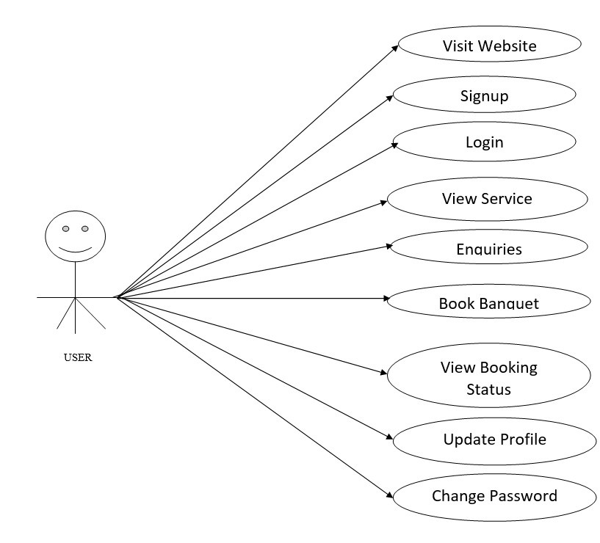

**User Use Case Diagram**

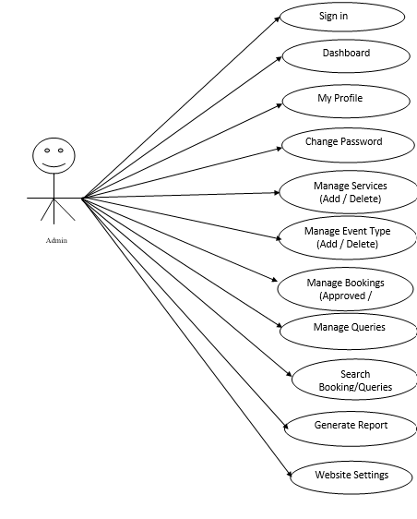

**Admin Use Case Diagram**

**ENTITY – RELATIONSHIP DIAGRAM:**

ER diagram is a popular high level conceptual data model and its variations are frequently used for the conceptual design of the database design tools employ its concepts. It is used in the design of conceptual schemas for database applications.

**ENTITIES AND ATTRIBUTES:**

The basic object that the ER model represents is an entity, which is a “thing” in the real world with an independent existence. An entity may be object with a physical existence a particular person car or employee or it may be an object with conceptual existence particular properties that describes it.

Ex: A client entity may be described by the client name, client project name etc. A particular entity will have a value for each of its attributes.

These are following types of attributes:

* Simple
* Composite
* Single valued
* Stored
* Derived
* Multi valued

**ER DIAGRAM**

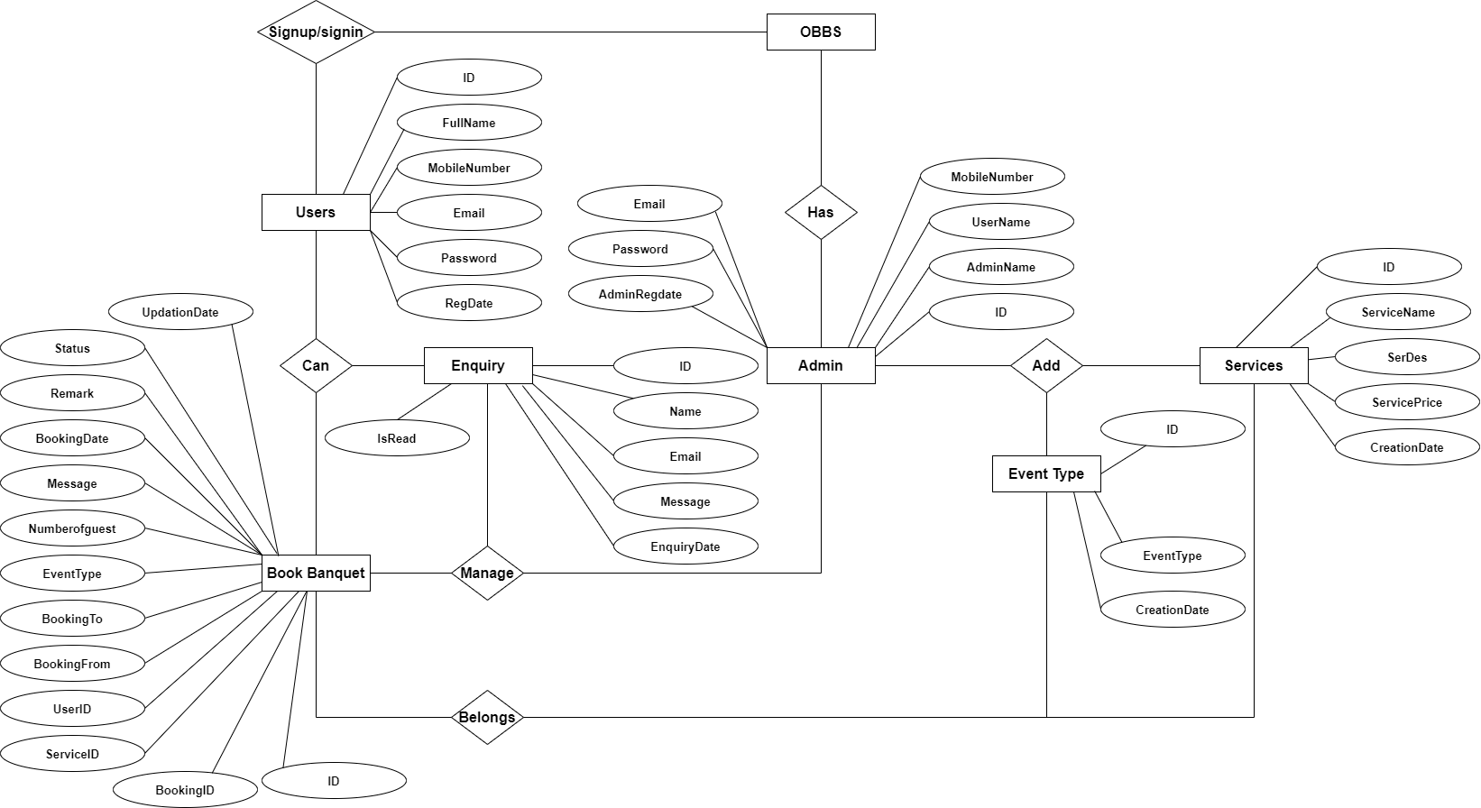

**10.**

**Database**

**Design**

**DATABASE DESIGN**

The overall objective in the development of database technology has been to treat data as an organizational resource and as an integrated whole. DBMS allow data to be protected and organized separately from other resources. Database is an integrated collection of data. The most significant form of data as seen by the programmers is data as stored on the direct access storage devices. This is the difference between logical and physical data.

Database files are the key source of information into the system. It is the process of designing database files, which are the key source of information to the system. The files should be properly designed and planned for collection, accumulation, editing and retrieving the required information.

The organization of data in database aims to achieve three major objectives:

* Data integration.
* Data integrity.
* Data independence.

The proposed system stores the information relevant for processing in the MS SQL SERVER 2000 database. This database contains tables, where each table corresponds to one particular type of information. Each piece of information in table is called a field or column. A table also contains records, which is a set of fields. All records in a table have the same set of fields with different information. There are primary key fields that uniquely identify a record in a table. There are also fields that contain primary key from another table called foreign keys.

**Tables**

The data in the system has to be stored and retrieved from database. Designing the database is part of system design. Data elements and data structures to be stored have been identified at analysis stage. They are structured and put together to design the data storage and retrieval system.

A database is a collection of interrelated data stored with minimum redundancy to serve many users quickly and efficiently. The general objective is to make database access easy, quick, inexpensive and flexible for the user. Relationships are established between the data items and unnecessary data items are removed. Normalization is done to get an internal consistency of data and to have minimum redundancy and maximum stability. This ensures minimizing data storage required, minimizing chances of data inconsistencies and optimizing for updates. The MySQL database has been chosen for developing the relevant databases.

**Online Banquet Booking System (OBBS) contains 7 MySQL tables:**

**tbladmin :** This table store the admin login details

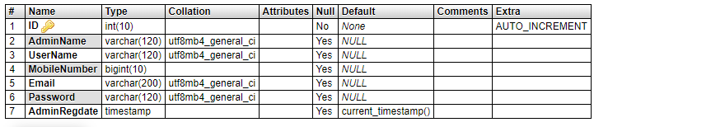

**tblbooking:** This table store the booking details.

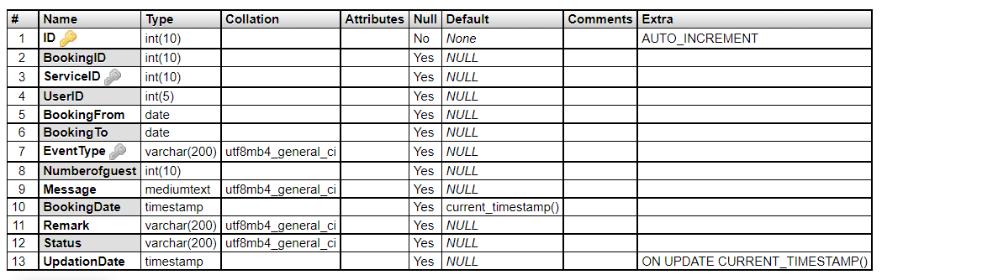

**tbleventtype:** This table store the type of event details.



**tblpage:** This table about us and contact us detail.

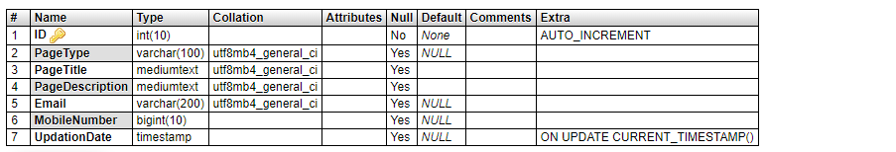

**tblservice:** This table store the details of banquet services.

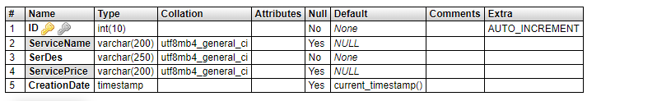

**tbluser:** This table store the details of registered user

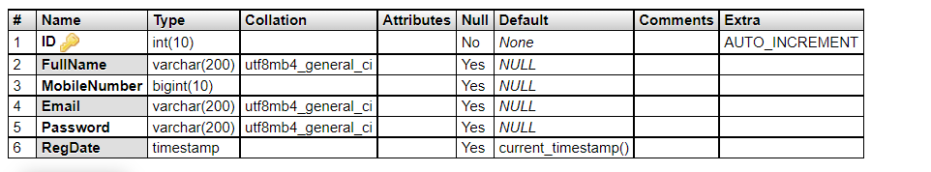

**tblcontact:** This table store the details of enquires.

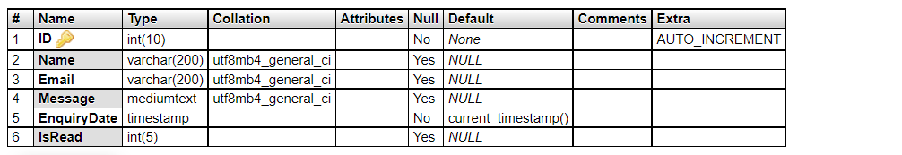. They are structured and put together to design the data storage and retrieval system.

A database is a collection of interrelated data stored with minimum redundancy to serve many users quickly and efficiently. The general objective is to make database access easy, quick, inexpensive and flexible for the user. Relationships are established between the data items and unnecessary data items are removed. Normalization is done to get an internal consistency of data and to have minimum redundancy and maximum stability. This ensures minimizing data storage required, minimizing chances of data inconsistencies and optimizing for updates. The MySQL database has been chosen for developing the relevant databases.

**Online Banquet Booking System (OBBS) contains 7 MySQL tables:**

**tbladmin :** This table store the admin login details



**tblbooking:** This table store the booking details.



**tbleventtype:** This table store the type of event details.



**tblpage:** This table about us and contact us detail.



**tblservice:** This table store the details of banquet services.



**tbluser:** This table store the details of registered user



**tblcontact:** This table store the details of enquires.



**11.**

**Coding**

**Login Registration page:**

<?php

include('includes/dbconnection.php');

session_start();

error_reporting(0);

if(isset($_POST['login']))

{

$email=$_POST['email'];

$password=md5($_POST['password']);

$sql ="SELECT ID FROM tbluser WHERE Email=:email and Password=:password";

$query=$dbh->prepare($sql);

$query->bindParam(':email',$email,PDO::PARAM_STR);

$query-> bindParam(':password', $password, PDO::PARAM_STR);

$query-> execute();

$results=$query->fetchAll(PDO::FETCH_OBJ);

if($query->rowCount() > 0)

{

foreach ($results as $result) {

$_SESSION['obbsuid']=$result->ID;

}

$_SESSION['login']=$_POST['email'];

echo "<script type='text/javascript'> document.location ='index.php'; </script>";

} else{

echo "<script>alert('Invalid Details');</script>";

}

}

?>

<!DOCTYPE html>

<html lang="en">

<head>

<title>Online Banquet Booking System | Login</title>

<script type="application/x-javascript"> addEventListener("load", function() { setTimeout(hideURLbar, 0); }, false); function hideURLbar(){ window.scrollTo(0,1); } </script>

<!-- bootstrap-css -->

<link href="css/bootstrap.css" rel="stylesheet" type="text/css" media="all" />

<!--// bootstrap-css -->

<!-- css -->

<link rel="stylesheet" href="css/style.css" type="text/css" media="all" />

<!--// css -->

<!-- font-awesome icons -->

<link href="css/font-awesome.css" rel="stylesheet">

<!-- //font-awesome icons -->

<!-- font -->

<link href="//fonts.googleapis.com/css?family=Josefin+Sans:100,100i,300,300i,400,400i,600,600i,700,700i" rel="stylesheet">

<link href='//fonts.googleapis.com/css?family=Roboto+Condensed:400,700italic,700,400italic,300italic,300' rel='stylesheet' type='text/css'>

<!-- //font -->

<script src="js/jquery-1.11.1.min.js"></script>

<script src="js/bootstrap.js"></script>

<script type="text/javascript">

jQuery(document).ready(function($) {

$(".scroll").click(function(event){

event.preventDefault();

$('html,body').animate({scrollTop:$(this.hash).offset().top},1000);

});

});

</script>

<!--[if lt IE 9]>

<script src="https://oss.maxcdn.com/libs/html5shiv/3.7.0/html5shiv.js"></script>

<![endif]-->

</head>

<body>

<!-- banner -->

<div class="banner jarallax">

<div class="agileinfo-dot">

<?php include_once('includes/header.php');?>

<div class="wthree-heading">

<h2>Login</h2>

</div>

</div>

</div>

<!-- //banner -->

<!-- contact -->

<div class="contact">

<div class="container">

<div class="agile-contact-form">

<div class="col-md-6 contact-form-left">

<div class="agileits-contact-address">

<img src="images/5.jpg" alt="" height="500" width="500">

</div>

</div>

<div class="col-md-6 contact-form-right">

<div class="contact-form-top">

<h3>Login to User Panel</h3>

</div>

<div class="agileinfo-contact-form-grid">

<form action="#" method="post" name="login">

<input type="email" name="email" placeholder="E-mail" required="true">

<input type="password" name="password" placeholder="Password" required="true">

<br>

<div class="forgot">

<a href="forgot-password.php">Forgot Password?</a>

</div>

<br>

<button class="btn1" name="login">LOGIN NOW</button>

</form>

</div>

</div>

<br>

<div class="col-md-6 contact-form-right">

<div class="forgot">

<a href="signup.php">Register Yourself</a>

</div>

</div>

<div class="clearfix"> </div>

</div>

</div>

</div>

<!-- //contact -->

<?php include_once('includes/footer.php');?>

<!-- jarallax -->

<script src="js/jarallax.js"></script>

<script src="js/SmoothScroll.min.js"></script>

<script type="text/javascript">

/* init Jarallax */

$('.jarallax').jarallax({

speed: 0.5,

imgWidth: 1366,

imgHeight: 768

})

</script>

<!-- //jarallax -->

<script src="js/SmoothScroll.min.js"></script>

<script type="text/javascript" src="js/move-top.js"></script>

<script type="text/javascript" src="js/easing.js"></script>

<!-- here stars scrolling icon -->

<script type="text/javascript">

$(document).ready(function() {

/*

var defaults = {

containerID: 'toTop', // fading element id

containerHoverID: 'toTopHover', // fading element hover id

scrollSpeed: 1200,

easingType: 'linear'

};

*/

$().UItoTop({ easingType: 'easeOutQuart' });

});

</script>

<!-- //here ends scrolling icon -->

<script src="js/modernizr.custom.js"></script>

</body>

</html> <?php

include('includes/dbconnection.php');

session_start();

error_reporting(0);

if(isset($_POST['login']))

{

$email=$_POST['email'];

$password=md5($_POST['password']);

$sql ="SELECT ID FROM tbluser WHERE Email=:email and Password=:password";

$query=$dbh->prepare($sql);

$query->bindParam(':email',$email,PDO::PARAM_STR);

$query-> bindParam(':password', $password, PDO::PARAM_STR);

$query-> execute();

$results=$query->fetchAll(PDO::FETCH_OBJ);

if($query->rowCount() > 0)

{

foreach ($results as $result) {

$_SESSION['obbsuid']=$result->ID;

}

$_SESSION['login']=$_POST['email'];

echo "<script type='text/javascript'> document.location ='index.php'; </script>";

} else{

echo "<script>alert('Invalid Details');</script>";

}

}

?>

<!DOCTYPE html>

<html lang="en">

<head>

<title>Online Banquet Booking System | Login</title>

<script type="application/x-javascript"> addEventListener("load", function() { setTimeout(hideURLbar, 0); }, false); function hideURLbar(){ window.scrollTo(0,1); }

</script>

<!-- bootstrap-css -->

<link href="css/bootstrap.css" rel="stylesheet" type="text/css" media="all" />

<!--// bootstrap-css -->

<!-- css -->

<link rel="stylesheet" href="css/style.css" type="text/css" media="all" />

<!--// css -->

<!-- font-awesome icons -->

<link href="css/font-awesome.css" rel="stylesheet">

<!-- //font-awesome icons -->

<!-- font -->

<link href="//fonts.googleapis.com/css?family=Josefin+Sans:100,100i,300,300i,400,400i,600,600i,700,700i" rel="stylesheet">

<link href='//fonts.googleapis.com/css?family=Roboto+Condensed:400,700italic,700,400italic,300italic,300' rel='stylesheet' type='text/css'>

<!-- //font -->

<script src="js/jquery-1.11.1.min.js"></script>

<script src="js/bootstrap.js"></script>

<script type="text/javascript">

jQuery(document).ready(function($) {

$(".scroll").click(function(event){

event.preventDefault();

$('html,body').animate({scrollTop:$(this.hash).offset().top},1000);

});

});

</script>

<!--[if lt IE 9]>

<script src="https://oss.maxcdn.com/libs/html5shiv/3.7.0/html5shiv.js"></script>

<![endif]-->

</head>

<body>

<!-- banner -->

<div class="banner jarallax">

<div class="agileinfo-dot">

<?php include_once('includes/header.php');?>

<div class="wthree-heading">

<h2>Login</h2>

</div>

</div>

</div>

<!-- //banner -->

<!-- contact -->

<div class="contact">

<div class="container">

<div class="agile-contact-form">

<div class="col-md-6 contact-form-left">

<div class="agileits-contact-address">

<img src="images/5.jpg" alt="" height="500" width="500">

</div>

</div>

<div class="col-md-6 contact-form-right">

<div class="contact-form-top">

<h3>Login to User Panel</h3>

</div>

<div class="agileinfo-contact-form-grid">

<form action="#" method="post" name="login">

<input type="email" name="email" placeholder="E-mail" required="true">

<input type="password" name="password" placeholder="Password" required="true">

<br>

<div class="forgot">

<a href="forgot-password.php">Forgot Password?</a>

</div>

<br>

<button class="btn1" name="login">LOGIN NOW</button>

</form>

</div>

</div>

<br>

<div class="col-md-6 contact-form-right">

<div class="forgot">

<a href="signup.php">Register Yourself</a>

</div>

</div>

<div class="clearfix"> </div>

</div>

</div>

</div>

<!-- //contact -->

<?php include_once('includes/footer.php');?>

<!-- jarallax -->

<script src="js/jarallax.js"></script>

<script src="js/SmoothScroll.min.js"></script>

<script type="text/javascript">

/* init Jarallax */

$('.jarallax').jarallax({

speed: 0.5,

imgWidth: 1366,

imgHeight: 768

})

</script>

<!-- //jarallax -->

<script src="js/SmoothScroll.min.js"></script>

<script type="text/javascript" src="js/move-top.js"></script>

<script type="text/javascript" src="js/easing.js"></script>

<!-- here stars scrolling icon -->

<script type="text/javascript">

$(document).ready(function() {

/*

var defaults = {

containerID: 'toTop', // fading element id

containerHoverID: 'toTopHover', // fading element hover id

scrollSpeed: 1200,

easingType: 'linear'

};

*/

$().UItoTop({ easingType: 'easeOutQuart' });

});

</script>

<!-- //here ends scrolling icon -->

<script src="js/modernizr.custom.js"></script>

</body>

</html>

**Service Booking Page:**

$eventtype=$_POST['eventtype'];

$nop=$_POST['nop'];

$message=$_POST['message'];

$bookingid=mt_rand(100000000, 999999999);

$sql="insert into tblbooking(BookingID,ServiceID,UserID,BookingFrom,BookingTo,EventType,Numberofguest,Message)values(:bookingid,:bid,:uid,:bookingfrom,:bookingto,:eventtype,:nop,:message)";

$query=$dbh->prepare($sql);

$query->bindParam(':bookingid',$bookingid,PDO::PARAM_STR);

$query->bindParam(':bid',$bid,PDO::PARAM_STR);

$query->bindParam(':uid',$uid,PDO::PARAM_STR);

$query->bindParam(':bookingfrom',$bookingfrom,PDO::PARAM_STR);

$query->bindParam(':bookingto',$bookingto,PDO::PARAM_STR);

$query->bindParam(':eventtype',$eventtype,PDO::PARAM_STR);

$query->bindParam(':nop',$nop,PDO::PARAM_STR);

$query->bindParam(':message',$message,PDO::PARAM_STR);

$query->execute();

$LastInsertId=$dbh->lastInsertId();

if ($LastInsertId>0) {

echo '<script>alert("Your Booking Request Has Been Send. We Will Contact You Soon")</script>';

echo "<script>window.location.href ='services.php'</script>";

}

else

{

echo '<script>alert("Something Went Wrong. Please try again")</script>';

}

}

?>

<!DOCTYPE html>

<html lang="en">

<head>

<title>Online Banquet Booking System | Book Services</title>

<script type="application/x-javascript"> addEventListener("load", function() { setTimeout(hideURLbar, 0); }, false); function hideURLbar(){ window.scrollTo(0,1); } </script>

<!-- bootstrap-css -->

<link href="css/bootstrap.css" rel="stylesheet" type="text/css" media="all" />

<!--// bootstrap-css -->

<!-- css -->

<link rel="stylesheet" href="css/style.css" type="text/css" media="all" />

<!--// css -->

<!-- font-awesome icons -->

<link href="css/font-awesome.css" rel="stylesheet">

<!-- //font-awesome icons -->

<!-- font -->

<link href="//fonts.googleapis.com/css?family=Josefin+Sans:100,100i,300,300i,400,400i,600,600i,700,700i" rel="stylesheet">

<link href='//fonts.googleapis.com/css?family=Roboto+Condensed:400,700italic,700,400italic,300italic,300' rel='stylesheet' type='text/css'>

<!-- //font -->

<script src="js/jquery-1.11.1.min.js"></script>

<script src="js/bootstrap.js"></script>

<script type="text/javascript">

jQuery(document).ready(function($) {

$(".scroll").click(function(event){

event.preventDefault();

$('html,body').animate({scrollTop:$(this.hash).offset().top},1000);

});

});

</script>

</head>

<body>

<!-- banner -->

<div class="banner jarallax">

<div class="agileinfo-dot">

<?php include_once('includes/header.php');?>

<div class="wthree-heading">

<h2>Book Services</h2>

</div>

</div>

</div>

<!-- //banner -->

<!-- contact -->

<div class="contact">

<div class="container">

<div class="agile-contact-form">

<div class="col-md-6 contact-form-right">

<div class="contact-form-top">

<h3>Book Services </h3>

</div>

<div class="agileinfo-contact-form-grid">

<form method="po

<div class="form-group row">

<label class="col-form-label col-md-4">Booking From:</label>

<div class="col-md-10">

<input type="date" class="form-control" style="font-size: 20px" required="true" name="bookingfrom">

</div>

</div>

<div class="form-group row">

<label class="col-form-label col-md-4">Booking To:</label>

<div class="col-md-10">

<input type="date" class="form-control" style="font-size: 20px" required="true" name="bookingto">

</div>

</div>

<div class="form-group row">

<label class="col-form-label col-md-4">Type of Event:</label>

<div class="col-md-10">

<select type="text" class="form-control" name="eventtype" required="true" >

<option value="">Choose Event Type</option>

<?php

$sql2 = "SELECT * from tbleventtype ";

$query2 = $dbh -> prepare($sql2);

$query2->execute();

$result2=$query2->fetchAll(PDO::FETCH_OBJ);

foreach($result2 as $row)

{

?>

<option value="<?php echo htmlentities($row->EventType);?>"><?php echo htmlentities($row->EventType);?></option>

<?php } ?>

</select>

</div>

</div>

<div class="form-group row">

<label class="col-form-label col-md-4">Number of Guest:</label>

<div class="col-md-10">

<input type="text" class="form-control" style="font-size: 20px" required="true" name="nop">

</div>

</div>

<div class="form-group row">

<label class="col-form-label col-md-4">Message(if any)</label>

<div class="col-md-10">

<textarea class="form-control" required="true" name="message" style="font-size: 20px"></textarea>

</div>

</div>

<br>

<div class="tp">

<button type="submit" class="btn btn-primary" name="submit">Book</button>

</div>

</form>

` </div>

</div>

<div class="clearfix"> </div>

</div>

</div>

</div>

<!-- //contact -->

<?php include_once('includes/footer.php');?>

<!-- jarallax -->

<script src="js/jarallax.js"></script>

<script src="js/SmoothScroll.min.js"></script>

<script type="text/javascript">

/* init Jarallax */

$('.jarallax').jarallax({

speed: 0.5,

imgWidth: 1366,

imgHeight: 768

})

</script>

<!-- //jarallax -->

<script src="js/SmoothScroll.min.js"></script>

<script type="text/javascript" src="js/move-top.js"></script>

<script type="text/javascript" src="js/easing.js"></script>

<!-- here stars scrolling icon -->

<script type="text/javascript">

$(document).ready(function()

{

/*

var defaults = {

containerID: 'toTop', // fading element id

containerHoverID: 'toTopHover', // fading element hover id

scrollSpeed: 1200,

easingType: 'linear'

};

*/

$().UItoTop({ easingType: 'easeOutQuart' });

});

</script>

<!-- //here ends scrolling icon -->

<script src="js/modernizr.custom.js"></script>

</body>

</html>

<?php }

?>

**//Services :**

<?php

session_start();

error_reporting(0);

include('includes/dbconnection.php');

?>

<!DOCTYPE html>

<html lang="en">

<head>

<title>Online Banquet Booking System|| About </title>

<script type="application/x-javascript"> addEventListener("load", function() { setTimeout(hideURLbar, 0); }, false); function hideURLbar(){ window.scrollTo(0,1); } </script>

<!-- bootstrap-css -->

<link href="css/bootstrap.css" rel="stylesheet" type="text/css" media="all" />

<!--// bootstrap-css -->

<!-- css -->

<link rel="stylesheet" href="css/style.css" type="text/css" media="all" />

<!--// css -->

<!-- font-awesome icons -->

<link href="css/font-awesome.css" rel="stylesheet">

<!-- //font-awesome icons -->

<!-- font -->

<link href="//fonts.googleapis.com/css?family=Josefin+Sans:100,100i,300,300i,400,400i,600,600i,700,700i" rel="stylesheet">

<link href='//fonts.googleapis.com/css?family=Roboto+Condensed:400,700italic,700,400italic,300italic,300' rel='stylesheet' type='text/css'>

<!-- //font -->

<script src="js/jquery-1.11.1.min.js"></script>

<script src="js/bootstrap.js"></script>

<script type="text/javascript">

jQuery(document).ready(function($) {

$(".scroll").click(function(event){

event.preventDefault();

$('html,body').animate({scrollTop:$(this.hash).offset().top},1000);

});

});

</script>

<!--[if lt IE 9]>

<script src="https://oss.maxcdn.com/libs/html5shiv/3.7.0/html5shiv.js"></script>

<![endif]-->

</head>

<body>

<!-- banner -->

<div class="banner jarallax">

<div class="agileinfo-dot">

<?php include_once('includes/header.php');?>

<div class="wthree-heading">

<h2>Services</h2>

</div>

</div>

</div>

<!-- //banner -->

<!-- about -->

<!-- about-top -->

<div class="about-top">

<div class="container">

<div class="wthree-services-bottom-grids">

<p class="wow fadeInUp animated" data-wow-delay=".5s">List of services which is prvided by us.</p>

<div class="bs-docs-example wow fadeInUp animated" data-wow-delay=".5s">

<table class="table table-bordered">

<thead>

<tr> <th>#</th> <th>Package Name</th>

<th>Description</th>

<th>Price</th>

<th>Action</th>

</tr>

</thead>

<tbody>

<?php

$sql="SELECT * from tblservice";

$query = $dbh -> prepare($sql);

$query->execute();

$results=$query->fetchAll(PDO::FETCH_OBJ);

$cnt=1;

if($query->rowCount() > 0)

{

foreach($results as $row)

{ ?>

<tr>

<td><?php echo htmlentities($cnt);?></td>

<td><?php echo htmlentities($row->ServiceName);?></td>

<td><?php echo htmlentities($row->SerDes);?></td>

<td>$<?php echo htmlentities($row->ServicePrice);?></td>

<?php if($_SESSION['obbsuid']==""){?>

<td><a href="login.php" class="btn btn-default">Book Services</a></td>

<?php } else {?>

<td><a href="book-services.php?bookid=<?php echo $row->ID;?>" class="btn btn-default">Book Services</a></td><?php }?>

</tr> <?php $cnt=$cnt+1;}} ?>

</tbody>

</table>

</div>

<div class="clearfix"> </div>

</div>

</div>

</div>

<!-- //about-top -->

<!-- //about -->

<!-- footer -->

<?php include_once('includes/footer.php');?>

<!-- jarallax -->

<script src="js/jarallax.js"></script>

<script src="js/SmoothScroll.min.js"></script>

<script type="text/javascript">

/* init Jarallax */

$('.jarallax').jarallax({

speed: 0.5,

imgWidth: 1366,

imgHeight: 768

})

</script>

<!-- //jarallax -->

<script src="js/SmoothScroll.min.js"></script>

<script type="text/javascript" src="js/move-top.js"></script>

<script type="text/javascript" src="js/easing.js"></script>

<!-- here stars scrolling icon -->

<script type="text/javascript">

$(document).ready(function() {

/*

var defaults = {

containerID: 'toTop', // fading element id

containerHoverID: 'toTopHover', // fading element hover id

scrollSpeed: 1200,

easingType: 'linear'

};

*/

$().UItoTop({ easingType: 'easeOutQuart' });

});

</script>

<!-- //here ends scrolling icon -->

<script src="js/modernizr.custom.js"></script>

</body>

</html>

**//Viewing Booking Details:**

<?php

session_start();

error_reporting(0);

include('includes/dbconnection.php');

if (strlen($_SESSION['obbsuid']==0)) {

header('location:logout.php');

} else{

?>

<!DOCTYPE html>

<html lang="en">

<head>

<title>Online Banquet Booking System|| View Booking </title>

<script type="application/x-javascript"> addEventListener("load", function() { setTimeout(hideURLbar, 0); }, false); function hideURLbar(){ window.scrollTo(0,1); } </script>

<!-- bootstrap-css -->

<link href="css/bootstrap.css" rel="stylesheet" type="text/css" media="all" />

<!--// bootstrap-css -->

<!-- css -->

<link rel="stylesheet" href="css/style.css" type="text/css" media="all" />

<!--// css -->

<!-- font-awesome icons -->

<link href="css/font-awesome.css" rel="stylesheet">

<!-- //font-awesome icons -->

<!-- font -->

<link href="//fonts.googleapis.com/css?family=Josefin+Sans:100,100i,300,300i,400,400i,600,600i,700,700i" rel="stylesheet">

<link href='//fonts.googleapis.com/css?family=Roboto+Condensed:400,700italic,700,400italic,300italic,300' rel='stylesheet' type='text/css'>

<!-- //font -->

<script src="js/jquery-1.11.1.min.js"></script>

<script src="js/bootstrap.js"></script>

<script type="text/javascript">

jQuery(document).ready(function($) {

$(".scroll").click(function(event){

event.preventDefault();

$('html,body').animate({scrollTop:$(this.hash).offset().top},1000);

});

});

</script>

<!--[if lt IE 9]>

<script src="https://oss.maxcdn.com/libs/html5shiv/3.7.0/html5shiv.js"></script>

<![endif]-->

</head>

<body>

<!-- banner -->

<div class="banner jarallax">

<div class="agileinfo-dot">

<?php include_once('includes/header.php');?>

<div class="wthree-heading">

<h2>View Booking</h2>

</div>

</div>

</div>

<!-- //banner -->

<!-- about -->

<!-- about-top -->

<div class="about-top">

<div class="container">

<div class="wthree-services-bottom-grids">

<p class="wow fadeInUp animated" data-wow-delay=".5s">View Your Booking Details.</p>

<div class="bs-docs-example wow fadeInUp animated" data-wow-delay=".5s">

<?php

$uid=$_SESSION['obbsuid'];

$sql="SELECT tbluser.FullName,tbluser.MobileNumber,tbluser.Email,tblbooking.BookingID,tblbooking.BookingDate,tblbooking.BookingFrom,tblbooking.BookingTo,tblbooking.EventType,tblbooking.Numberofguest,tblbooking.Message, tblbooking.Remark,tblbooking.Status,tblbooking.UpdationDate,tblservice.ServiceName,tblservice.SerDes,tblservice.ServicePrice,Remark from tblbooking join tblservice on tblbooking.ServiceID=tblservice.ID join tbluser on tbluser.ID=tblbooking.UserID where tblbooking.UserID=:uid";

$query = $dbh -> prepare($sql);

$query-> bindParam(':uid', $uid, PDO::PARAM_STR);

$query->execute();

$results=$query->fetchAll(PDO::FETCH_OBJ);

$cnt=1;

if($query->rowCount() > 0)

{

foreach($results as $row)

{ ?>

<table border="1" class="table table-bordered table-striped table-vcenter js-dataTable-full-pagination">

<tr>

<th colspan="5" style="text-align: center;font-size: 20px;color: blue;">Booking Number: <?php echo $row->BookingID;?>

</th>

</tr>

<tr>

<th>Client Name</th>

<td><?php echo $row->FullName;?></td>

<th>Mobile Number</th>

<td><?php echo $row->MobileNumber;?></td>

</tr>

<tr>

<th>Email</th>

<td><?php echo $row->Email;?></td>

<th>Booking From</th>

<td><?php echo $row->BookingFrom;?></td>

</tr>

<tr>

<th>Booking To</th>

<td><?php echo $row->BookingTo;?></td>

<th>Number of Guest</th>

<td><?php echo $row->Numberofguest;?></td>

</tr>

<tr>

<th>Event Type</th>

<td><?php echo $row->EventType;?></td>

<th>Message</th>

<td><?php echo $row->Message;?></td>

</tr>

<tr>

<th>Service Name</th>

<td><?php echo $row->ServiceName;?></td>

<th>Service Description</th>

<td><?php echo $row->SerDes;?></td>

</tr>

<tr>

<th>Service Price</th>

<td>$<?php echo $row->ServicePrice;?></td>

<th>Apply Date</th>

<td><?php echo $row->BookingDate;?></td>

</tr>

<tr>

<th>Order Final Status</th>

<td> <?php $status=$row->Status;

if($row->Status=="Approved")

{

echo "Approved";

}

if($row->Status=="Cancelled")

{

echo "Cancelled";

}

if($row->Status=="")

{

echo "Not Response Yet";

}

;?></td>

<th >Admin Remark</th>

<?php if($row->Status==""){ ?>

<td><?php echo "Not Updated Yet"; ?></td>

<?php } else { ?> <td><?php echo htmlentities($row->Remark);?>

</td>

<?php } ?>

</tr>

<?php $cnt=$cnt+1;}} ?>

</table>

</div>

<div class="clearfix"> </div>

</div>

</div>

</div>

<!-- //about-top -->

<!-- //about -->

<!-- footer -->

<?php include_once('includes/footer.php');?>

<!-- jarallax -->

<script src="js/jarallax.js"></script>

<script src="js/SmoothScroll.min.js"></script>

<script type="text/javascript">

/* init Jarallax */

$('.jarallax').jarallax({

speed: 0.5,

imgWidth: 1366,

imgHeight: 768

})

</script>

<!-- //jarallax -->

<script src="js/SmoothScroll.min.js"></script>

<script type="text/javascript" src="js/move-top.js"></script>

<script type="text/javascript" src="js/easing.js"></script>

<!-- here stars scrolling icon -->

<script type="text/javascript">

$(document).ready(function() {

/*

var defaults = {

containerID: 'toTop', // fading element id

containerHoverID: 'toTopHover', // fading element hover id

scrollSpeed: 1200,

easingType: 'linear'

};

*/

$().UItoTop({ easingType: 'easeOutQuart' });

});

</script>

<!-- //here ends scrolling icon -->

<script src="js/modernizr.custom.js"></script>

</body>

</html><?php } ?>

**//Admin Profile:**

<?php

session_start();

error_reporting(0);

include('includes/dbconnection.php');

if (strlen($_SESSION['odmsaid']==0)) {

header('location:logout.php');

} else{

if(isset($_POST['submit']))

{

$adminid=$_SESSION['odmsaid'];

$AName=$_POST['adminname'];

$mobno=$_POST['mobilenumber'];

$email=$_POST['email'];

$sql="update tbladmin set AdminName=:adminname,MobileNumber=:mobilenumber,Email=:email where ID=:aid";

$query = $dbh->prepare($sql);

$query->bindParam(':adminname',$AName,PDO::PARAM_STR);

$query->bindParam(':email',$email,PDO::PARAM_STR);

$query->bindParam(':mobilenumber',$mobno,PDO::PARAM_STR);

$query->bindParam(':aid',$adminid,PDO::PARAM_STR);

$query->execute();

echo '<script>alert("Profile has been updated")</script>';

}

?>

<!doctype html>

<html lang="en" class="no-focus"> <!--<![endif]-->

<head>

<title>Online Banquet Booking System - Admin Profile</title>

<link rel="stylesheet" id="css-main" href="assets/css/codebase.min.css">

</head>

<body>

<div id="page-container" class="sidebar-o sidebar-inverse side-scroll page-header-fixed main-content-narrow">

<?php include_once('includes/sidebar.php');?>

<?php include_once('includes/header.php');?>

<!-- Main Container -->

<main id="main-container">

<!-- Page Content -->

<div class="content">

<!-- Register Forms -->

<h2 class="content-heading">Admin Profile</h2>

<div class="row">

<div class="col-md-12">

<!-- Bootstrap Register -->

<div class="block block-themed">

<div class="block-header bg-gd-emerald">

<h3 class="block-title">Admin Profile</h3>

<div class="block-options">

<button type="button" class="btn-block-option" data-toggle="block-option" data-action="state_toggle" data-action-mode="demo">

<i class="si si-refresh"></i>

</button>

<button type="button" class="btn-block-option" data-toggle="block-option" data-action="content_toggle"></button>

</div>

</div>

<div class="block-content">

<?php

$sql="SELECT * from tbladmin";

$query = $dbh -> prepare($sql);

$query->execute();

$results=$query->fetchAll(PDO::FETCH_OBJ);

$cnt=1;

if($query->rowCount() > 0)

{

foreach($results as $row)

{ ?>

<form method="post">

<div class="form-group row">

<label class="col-12" for="register1-username">Admin Name:</label>

<div class="col-12">

<input type="text" class="form-control" name="adminname" value="<?php echo $row->AdminName;?>" required='true'>

</div>

</div>

<div class="form-group row">

<label class="col-12" for="register1-email">User Name:</label>

<div class="col-12">

<input type="text" class="form-control" name="username" value="<?php echo $row->UserName;?>" readonly="true">

</div>

</div>

<div class="form-group row">

<label class="col-12" for="register1-password">Email:</label>

<div class="col-12">

<input type="email" class="form-control" name="email" value="<?php echo $row->Email;?>" required='true'>

</div>

</div>

<div class="form-group row">

<label class="col-12" for="register1-password">Contact Number:</label>

<div class="col-12">

<input type="text" class="form-control" name="mobilenumber" value="<?php echo $row->MobileNumber;?>" required='true' maxlength='10'>

</div>

</div>

<div class="form-group row">

<label class="col-12" for="register1-password">Admin Registration Date:</label>

<div class="col-12">

<input type="text" class="form-control" id="email2" name="" value="<?php echo $row->AdminRegdate;?>" readonly="true">

</div>

</div>

<?php $cnt=$cnt+1;}} ?>

<div class="form-group row">

<div class="col-12">

<button type="submit" class="btn btn-alt-success" name="submit">

<i class="fa fa-plus mr-5"></i> Update

</button>

</div>

</div>

</form>

</div>

</div>

<!-- END Bootstrap Register -->

</div>

</div>

</div>

<!-- END Page Content -->

</main>

<!-- END Main Container -->

<?php include_once('includes/footer.php');?>

</div>

<!-- END Page Container -->

<!-- Codebase Core JS -->

<script src="assets/js/core/jquery.min.js"></script>

<script src="assets/js/core/popper.min.js"></script>

<script src="assets/js/core/bootstrap.min.js"></script>

<script src="assets/js/core/jquery.slimscroll.min.js"></script>

<script src="assets/js/core/jquery.scrollLock.min.js"></script>

<script src="assets/js/core/jquery.appear.min.js"></script>

<script src="assets/js/core/jquery.countTo.min.js"></script>

<script src="assets/js/core/js.cookie.min.js"></script>

<script src="assets/js/codebase.js"></script>

</body>

</html>

<?php } ?>

**//Admin Login :**

<?php

session_start();

error_reporting(0);

include('includes/dbconnection.php');

if(isset($_POST['login']))

{

$username=$_POST['username'];

$password=md5($_POST['password']);

$sql ="SELECT ID FROM tbladmin WHERE UserName=:username and Password=:password";

$query=$dbh->prepare($sql);

$query-> bindParam(':username', $username, PDO::PARAM_STR);

$query-> bindParam(':password', $password, PDO::PARAM_STR);

$query-> execute();

$results=$query->fetchAll(PDO::FETCH_OBJ);

if($query->rowCount() > 0)

{

foreach ($results as $result) {

$_SESSION['odmsaid']=$result->ID;

}

if(!empty($_POST["remember"])) {

//COOKIES for username

setcookie ("user_login",$_POST["username"],time()+ (10 * 365 * 24 * 60 * 60));

//COOKIES for password

setcookie ("userpassword",$_POST["password"],time()+ (10 * 365 * 24 * 60 * 60));

} else {

if(isset($_COOKIE["user_login"])) {

setcookie ("user_login","");

if(isset($_COOKIE["userpassword"])) {

setcookie ("userpassword","");

}

}

}

$_SESSION['login']=$_POST['username'];

echo "<script type='text/javascript'> document.location ='dashboard.php'; </script>";

} else{

echo "<script>alert('Invalid Details');</script>";

}

}

?>

<!doctype html>

<html lang="en" class="no-focus"> <!--<![endif]-->

<head>

<title>Online Banquet Booking System - Login Page</title>

<link rel="stylesheet" id="css-main" href="assets/css/codebase.min.css">

</head>

<body>

<div id="page-container" class="main-content-boxed">

<!-- Main Container -->

<main id="main-container">

<!-- Page Content -->

<div class="bg-image" style="background-image: url('assets/img/photos/photo34@2x.jpg');">

<div class="row mx-0 bg-black-op">

<div class="hero-static col-md-6 col-xl-8 d-none d-md-flex align-items-md-end">

<div class="p-30 invisible" data-toggle="appear">

<p class="font-size-h3 font-w600 text-white">

Online Banquet Booking System.

</p>

<p class="font-italic text-white-op">

Copyright &copy; <span class="js-year-copy">2020</span>

</p>

</div>

</div>

<div class="hero-static col-md-6 col-xl-4 d-flex align-items-center bg-white invisible" data-toggle="appear" data-class="animated fadeInRight">

<div class="content content-full">

<!-- Header -->

<div class="px-30 py-10">

<a class="link-effect font-w700" href="login.php">

<i class="si si-fire"></i>

<span class="font-size-xl">OBBS</span>

</a>

<h1 class="h3 font-w700 mt-30 mb-10">Welcome to Your Dashboard</h1>

<h2 class="h5 font-w400 text-muted mb-0">Please sign in</h2>

</div>

<form class="js-validation-signin px-30" method="post">

<div class="form-group row">

<div class="col-12">

<div class="form-material floating">

<input type="text" class="form-control" required="true" name="username" value="<?php if(isset($_COOKIE["user_login"])) { echo $_COOKIE["user_login"]; } ?>">

<label for="login-username">Username</label>

</div>

</div>

</div>

<div class="form-group row">

<div class="col-12">

<div class="form-material floating">

<input type="password" class="form-control" name="password" required="true" value="<?php if(isset($_COOKIE["userpassword"])) { echo $_COOKIE["userpassword"]; } ?>">

<label for="login-password">Password</label>

</div>

</div>

</div>

<div class="form-group row">

<div class="checkbox checkbox-primary">

<input type="checkbox" id="remember" name="remember" <?php if(isset($_COOKIE["user_login"])) { ?> checked <?php } ?> />

<label for="keep_me_logged_in">Keep me signed in</label>

</div>

</div>

<div class="form-group">

<button type="submit" class="btn btn-sm btn-hero btn-alt-primary" name="login">

<i class="si si-login mr-10"></i> Sign In

</button>

<div class="mt-30">

<a class="link-effect text-muted mr-10 mb-5 d-inline-block" href="forgot-password.php">

<i class="fa fa-warning mr-5"></i> Forgot Password

</a>

<a href="../index.php">Back Home!!</a>

</div>

</div>

</form>

<!-- END Sign In Form -->

</div>

</div>

</div>

</div>

<!-- END Page Content -->

</main>

<!-- END Main Container -->

</div>

<!-- END Page Container -->

<!-- Codebase Core JS -->

<script src="assets/js/core/jquery.min.js"></script>

<script src="assets/js/core/popper.min.js"></script>

<script src="assets/js/core/bootstrap.min.js"></script>

<script src="assets/js/core/jquery.slimscroll.min.js"></script>

<script src="assets/js/core/jquery.scrollLock.min.js"></script>

<script src="assets/js/core/jquery.appear.min.js"></script>

<script src="assets/js/core/jquery.countTo.min.js"></script>

<script src="assets/js/core/js.cookie.min.js"></script>

<script src="assets/js/codebase.js"></script>

<!-- Page JS Plugins -->

<script src="assets/js/plugins/jquery-validation/jquery.validate.min.js"></script>

<!-- Page JS Code -->

<script src="assets/js/pages/op_auth_signin.js"></script>

</body>

</html>

**//Adding a new Services To the User :**

<?php

session_start();

error_reporting(0);

include('includes/dbconnection.php');

if (strlen($_SESSION['odmsaid']==0)) {

header('location:logout.php');

} else{

if(isset($_POST['submit']))

{

$sername=$_POST['sername'];

$serdes=$_POST['serdes'];

$serprice=$_POST['serprice'];

$sql="insert into tblservice(ServiceName,SerDes,ServicePrice)values(:sername,:serdes,:serprice)";

$query=$dbh->prepare($sql);

$query->bindParam(':sername',$sername,PDO::PARAM_STR);

$query->bindParam(':serdes',$serdes,PDO::PARAM_STR);

$query->bindParam(':serprice',$serprice,PDO::PARAM_STR);

$query->execute();

$LastInsertId=$dbh->lastInsertId();

if ($LastInsertId>0) {

echo '<script>alert("Services has been added.")</script>';

echo "<script>window.location.href ='add-services.php'</script>";

}

else

{

echo '<script>alert("Something Went Wrong. Please try again")</script>';

}

}

?>

<!doctype html>

<html lang="en" class="no-focus"> <!--<![endif]-->

<head>

<title>Online Banquet Booking System - Add Services</title>

<link rel="stylesheet" id="css-main" href="assets/css/codebase.min.css">

</head>

<body>

<div id="page-container" class="sidebar-o sidebar-inverse side-scroll page-header-fixed main-content-narrow">

<?php include_once('includes/sidebar.php');?>

<?php include_once('includes/header.php');?>

<!-- Main Container -->

<main id="main-container">

<!-- Page Content -->

<div class="content">

<!-- Register Forms -->

<h2 class="content-heading">Add Services</h2>

<div class="row">

<div class="col-md-12">

<!-- Bootstrap Register -->

<div class="block block-themed">

<div class="block-header bg-gd-emerald">

<h3 class="block-title">Add Services</h3>

<div class="block-options">

<button type="button" class="btn-block-option" data-toggle="block-option" data-action="state_toggle" data-action-mode="demo">

<i class="si si-refresh"></i>

</button>

<button type="button" class="btn-block-option" data-toggle="block-option" data-action="content_toggle"></button>

</div>

</div>

<div class="block-content">

<form method="post">

<div class="form-group row">

<label class="col-12" for="register1-email">Service Name:</label>

<div class="col-12">

<input type="text" class="form-control" name="sername" value="" required='true'>

</div>

</div>

<div class="form-group row">

<label class="col-12" for="register1-email">Service Description:</label>

<div class="col-12">

<textarea type="text" class="form-control" name="serdes" value="" required='true'></textarea>

</div>

</div>

<div class="form-group row">

<label class="col-12" for="register1-password">Service Price:</label>

<div class="col-12">

<input type="text" class="form-control" name="serprice" value="" required='true'>

</div>

</div>

<div class="form-group row">

<div class="col-12">

<button type="submit" class="btn btn-alt-success" name="submit">

<i class="fa fa-plus mr-5"></i> Add

</button>

</div>

</div>

</form>

</div>

</div>

<!-- END Bootstrap Register -->

</div>

</div>

</div>

<!-- END Page Content -->

</main>

<!-- END Main Container -->

<?php include_once('includes/footer.php');?>

</div>

<!-- END Page Container -->

<!-- Codebase Core JS -->

<script src="assets/js/core/jquery.min.js"></script>

<script src="assets/js/core/popper.min.js"></script>

<script src="assets/js/core/bootstrap.min.js"></script>

<script src="assets/js/core/jquery.slimscroll.min.js"></script>

<script src="assets/js/core/jquery.scrollLock.min.js"></script>

<script src="assets/js/core/jquery.appear.min.js"></script>

<script src="assets/js/core/jquery.countTo.min.js"></script>

<script src="assets/js/core/js.cookie.min.js"></script>

<script src="assets/js/codebase.js"></script>

</body>

</html>

<?php }

?>

**//Booking Status:**

<?php

session_start();

error_reporting(0);

include('includes/dbconnection.php');

if (strlen($_SESSION['odmsaid']==0)) {

header('location:logout.php');

} else{

?>

<!doctype html>

<html lang="en" class="no-focus"> <!--<![endif]-->

<head>

<title>Online Banquet Booking System - Approved Booking</title>

<link rel="stylesheet" href="assets/js/plugins/datatables/dataTables.bootstrap4.min.css">

<link rel="stylesheet" id="css-main" href="assets/css/codebase.min.css">

</head>

<body>

<div id="page-container" class="sidebar-o sidebar-inverse side-scroll page-header-fixed main-content-narrow">

<?php include_once('includes/sidebar.php');?>

<?php include_once('includes/header.php');?>

<!-- Main Container -->

<main id="main-container">

<!-- Page Content -->

<div class="content">

<h2 class="content-heading">Approved Booking</h2>

<!-- Dynamic Table Full Pagination -->

<div class="block">

<div class="block-header block-header-default">

<h3 class="block-title">Approved Booking</h3>

</div>

<div class="block-content block-content-full">

<!-- DataTables init on table by adding .js-dataTable-full-pagination class, functionality initialized in js/pages/be_tables_datatables.js -->

<table class="table table-bordered table-striped table-vcenter js-dataTable-full-pagination">

<thead>

<tr>

<th class="text-center"></th>

<th>Booking ID</th>

<th class="d-none d-sm-table-cell">Cutomer Name</th>

<th class="d-none d-sm-table-cell">Mobile Number</th>

<th class="d-none d-sm-table-cell">Email</th>

<th class="d-none d-sm-table-cell">Booking Date</th>

<th class="d-none d-sm-table-cell">Status</th>

<th class="d-none d-sm-table-cell" style="width: 15%;">Action</th>

</tr>

</thead>

<tbody>

<?php

$sql="SELECT tbluser.FullName,tbluser.MobileNumber,tbluser.Email,tblbooking.ID as bid,tblbooking.BookingID,tblbooking.BookingDate,tblbooking.Status,tblbooking.ID from tblbooking join tbluser on tbluser.ID=tblbooking.UserID where tblbooking.Status='Approved'";

$query = $dbh -> prepare($sql);

$query->execute();

$results=$query->fetchAll(PDO::FETCH_OBJ);

$cnt=1;

if($query->rowCount() > 0)

{

foreach($results as $row)

{ ?>

<tr>

<td class="text-center"><?php echo htmlentities($cnt);?></td>

<td class="font-w600"><?php echo htmlentities($row->BookingID);?></td>

<td class="font-w600"><?php echo htmlentities($row->FullName);?></td>

<td class="font-w600"><?php echo htmlentities($row->MobileNumber);?></td>

<td class="font-w600"><?php echo htmlentities($row->Email);?></td>

<td class="font-w600">

<span class="badge badge-primary"><?php echo htmlentities($row->BookingDate);?></span>

</td>

<?php if($row->Status==""){ ?>

<td class="font-w600"><?php echo "Not Updated Yet"; ?></td>

<?php } else { ?>

<td class="d-none d-sm-table-cell">

<span class="badge badge-primary"><?php echo htmlentities($row->Status);?></span>

</td>

<?php } ?>

<td class="d-none d-sm-table-cell"><a href="view-booking-detail.php?editid=<?php echo htmlentities ($row->ID);?>"><i class="fa fa-eye" aria-hidden="true"></i></a></td>

</tr>

<?php $cnt=$cnt+1;}} ?>

</tbody>

</table>

</div>

</div>

<!-- END Dynamic Table Full Pagination -->

<!-- END Dynamic Table Simple -->

</div>

<!-- END Page Content -->

</main>

<!-- END Main Container -->

<?php include_once('includes/footer.php');?>

</div>

<!-- END Page Container -->

<!-- Codebase Core JS -->

<script src="assets/js/core/jquery.min.js"></script>

<script src="assets/js/core/popper.min.js"></script>

<script src="assets/js/core/bootstrap.min.js"></script>

<script src="assets/js/core/jquery.slimscroll.min.js"></script>

<script src="assets/js/core/jquery.scrollLock.min.js"></script>

<script src="assets/js/core/jquery.appear.min.js"></script>

<script src="assets/js/core/jquery.countTo.min.js"></script>

<script src="assets/js/core/js.cookie.min.js"></script>

<script src="assets/js/codebase.js"></script>

<!-- Page JS Plugins -->

<script src="assets/js/plugins/datatables/jquery.dataTables.min.js"></script>

<script src="assets/js/plugins/datatables/dataTables.bootstrap4.min.js"></script>

<!-- Page JS Code -->

<script src="assets/js/pages/be_tables_datatables.js"></script>

</body>

</html>

<?php }

?>

**//View User Queries:**

<?php

session_start();

error_reporting(0);

include('includes/dbconnection.php');

if (strlen($_SESSION['odmsaid']==0)) {

header('location:logout.php');

} else{

$vid=$_GET['viewid'];

$isread=1;

$sql="update tblcontact set IsRead=:isread where ID=:vid";

$query=$dbh->prepare($sql);

$query->bindParam(':isread',$isread,PDO::PARAM_STR);

$query->bindParam(':vid',$vid,PDO::PARAM_STR);

$query->execute();

?>

<!doctype html>

<html lang="en" class="no-focus"> <!--<![endif]-->

<head>

<title>Online Banquet Booking System - View Queries</title>

<link rel="stylesheet" href="assets/js/plugins/datatables/dataTables.bootstrap4.min.css">

<link rel="stylesheet" id="css-main" href="assets/css/codebase.min.css">

</head>

<body>

<div id="page-container" class="sidebar-o sidebar-inverse side-scroll page-header-fixed main-content-narrow">

<?php include_once('includes/sidebar.php');?>

<?php include_once('includes/header.php');?>

<!-- Main Container -->

<main id="main-container">

<!-- Page Content -->

<div class="content">

<h2 class="content-heading">View Queries</h2>

<!-- Dynamic Table Full Pagination -->

<div class="block">

<div class="block-header block-header-default">

<h3 class="block-title">View Queries</h3>

</div>

<div class="block-content block-content-full">

<!-- DataTables init on table by adding .js-dataTable-full-pagination class, functionality initialized in js/pages/be_tables_datatables.js -->

<?php

$sql="SELECT * from tblcontact where ID=$vid";

$query = $dbh -> prepare($sql);

$query->execute();

$results=$query->fetchAll(PDO::FETCH_OBJ);

$cnt=1;

if($query->rowCount() > 0)

{

foreach($results as $row)

{ ?>

<table class="table table-bordered table-striped table-vcenter js-dataTable-full-pagination">

<tr align="center">

<td colspan="4" style="font-size:20px;color:blue">

View Queries</td></tr>

<tr>

<th scope>Name</th>

<td><?php echo ($row->Name);?></td>

</tr>

<tr>

<th scope>Email</th>

<td><?php echo ($row->Email);?></td>

</tr>

<tr><th >Message</th>

<td colspan="3"><?php echo ($row->Message);?></td></tr>

<?php $cnt=$cnt+1;}} ?>

</table>

</div>

</div>

<!-- END Dynamic Table Full Pagination -->

<!-- END Dynamic Table Simple -->

</div>

<!-- END Page Content -->

</main>

<!-- END Main Container -->

<?php include_once('includes/footer.php');?>

</div>

<!-- END Page Container -->

<!-- Codebase Core JS -->

<script src="assets/js/core/jquery.min.js"></script>

<script src="assets/js/core/popper.min.js"></script>

<script src="assets/js/core/bootstrap.min.js"></script>

<script src="assets/js/core/jquery.slimscroll.min.js"></script>

<script src="assets/js/core/jquery.scrollLock.min.js"></script>

<script src="assets/js/core/jquery.appear.min.js"></script>

<script src="assets/js/core/jquery.countTo.min.js"></script>

<script src="assets/js/core/js.cookie.min.js"></script>

<script src="assets/js/codebase.js"></script>

<!-- Page JS Plugins -->

<script src="assets/js/plugins/datatables/jquery.dataTables.min.js"></script>

<script src="assets/js/plugins/datatables/dataTables.bootstrap4.min.js"></script>

<!-- Page JS Code -->

<script src="assets/js/pages/be_tables_datatables.js"></script>

</body>

</html>

<?php } ?>

**12.**

**Input and**

**Output**

**Screen Design**

**Home page:**

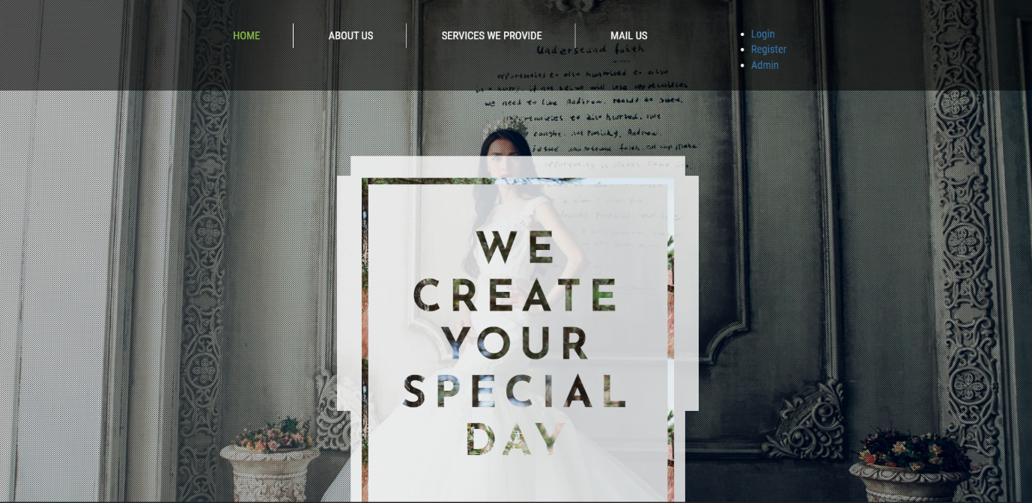

**Services we provide:**

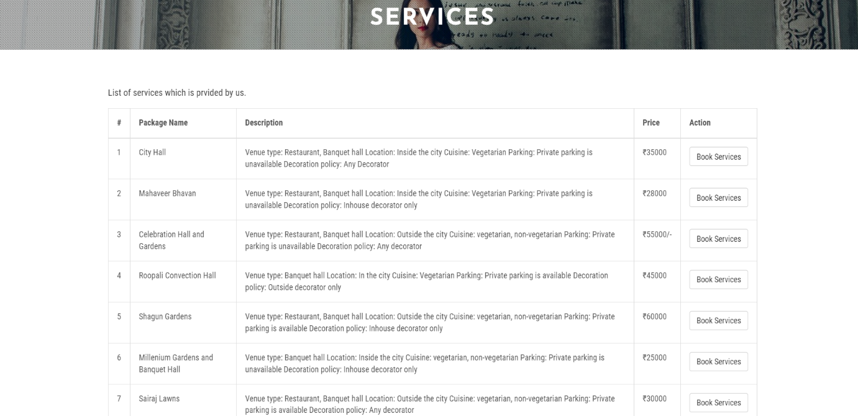

**Student Registration :**

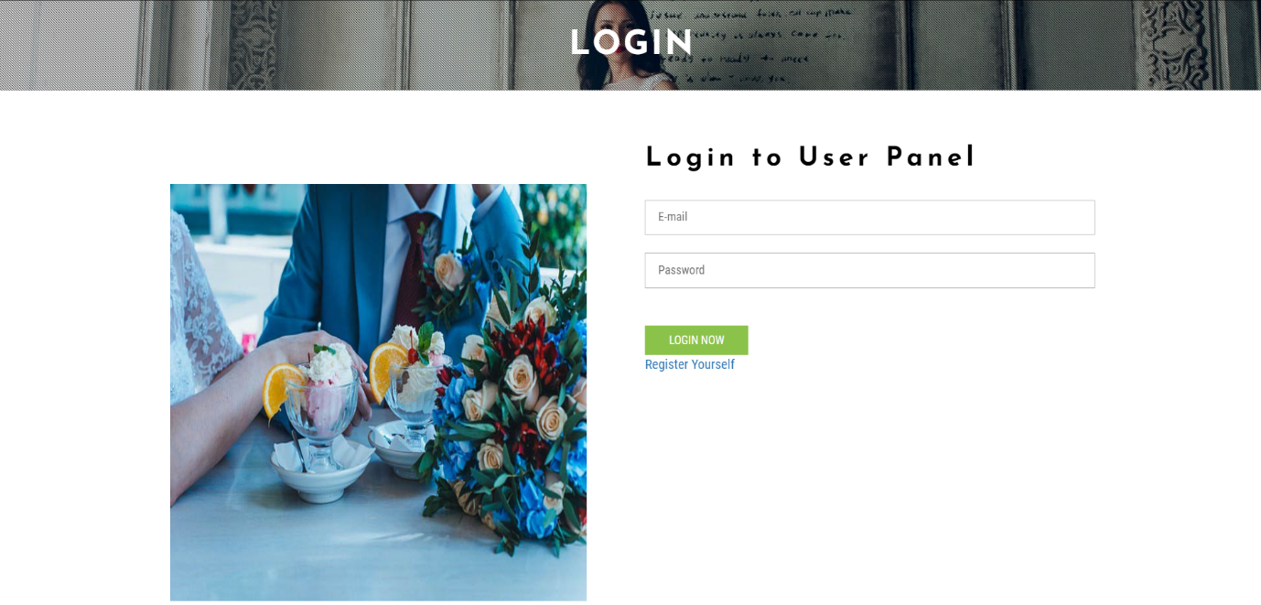

**User Profile:**

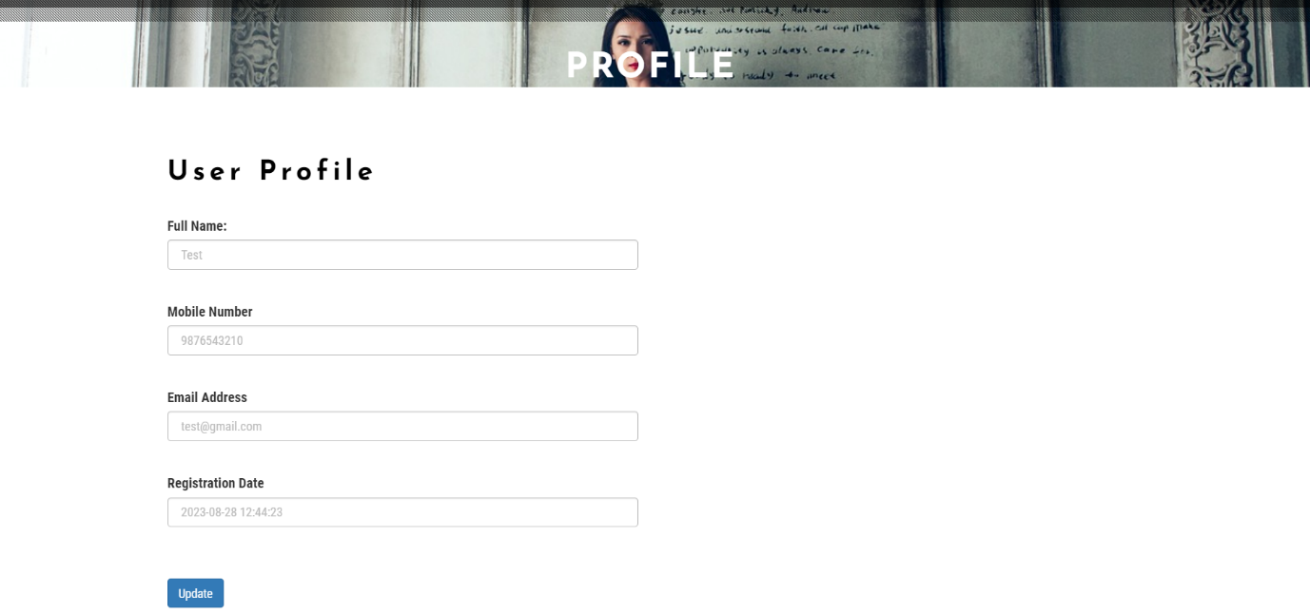

**Booking Status:**

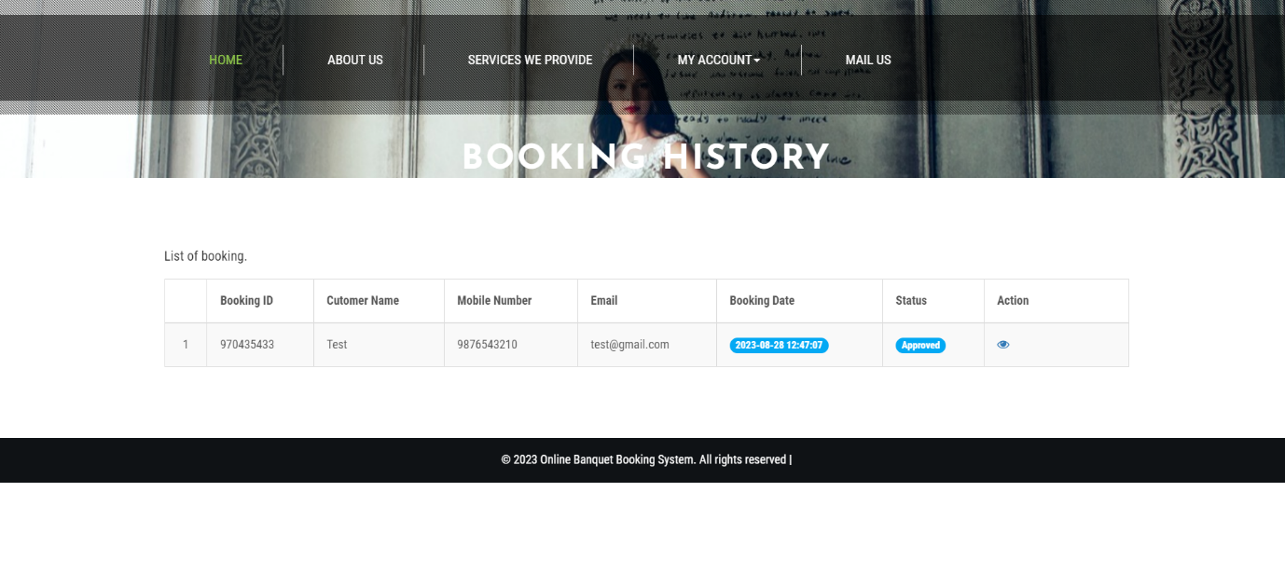

**Dashboard :**

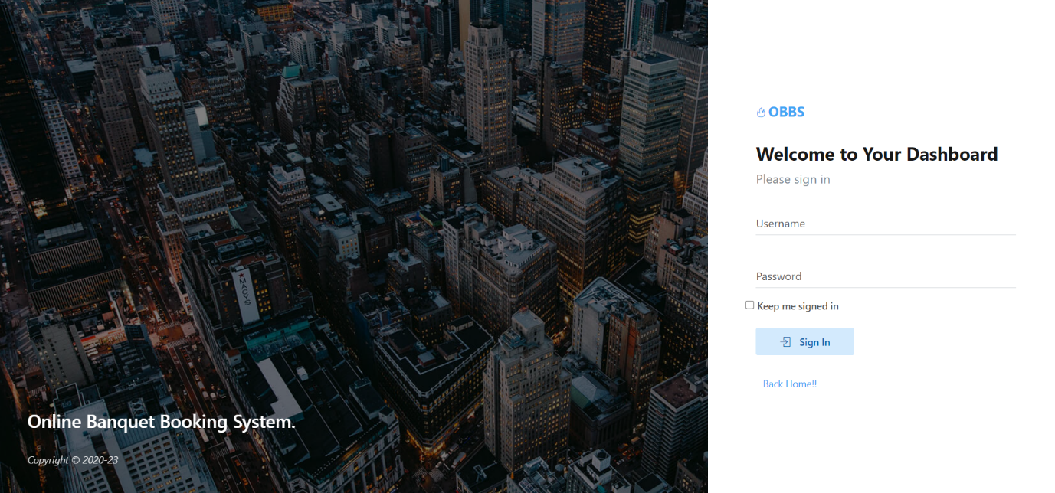

**Updating New Booking:**



**Updating New Services:**

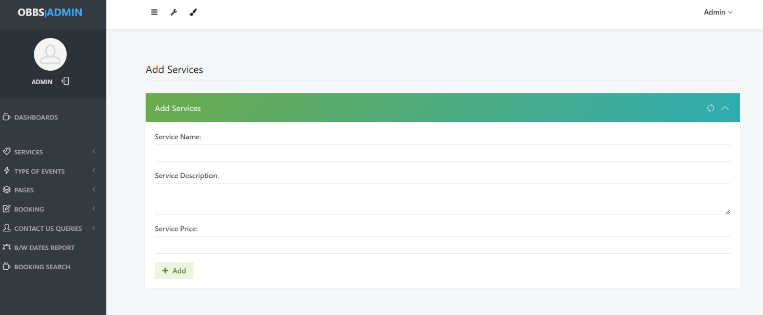

**Managing Event Types :**

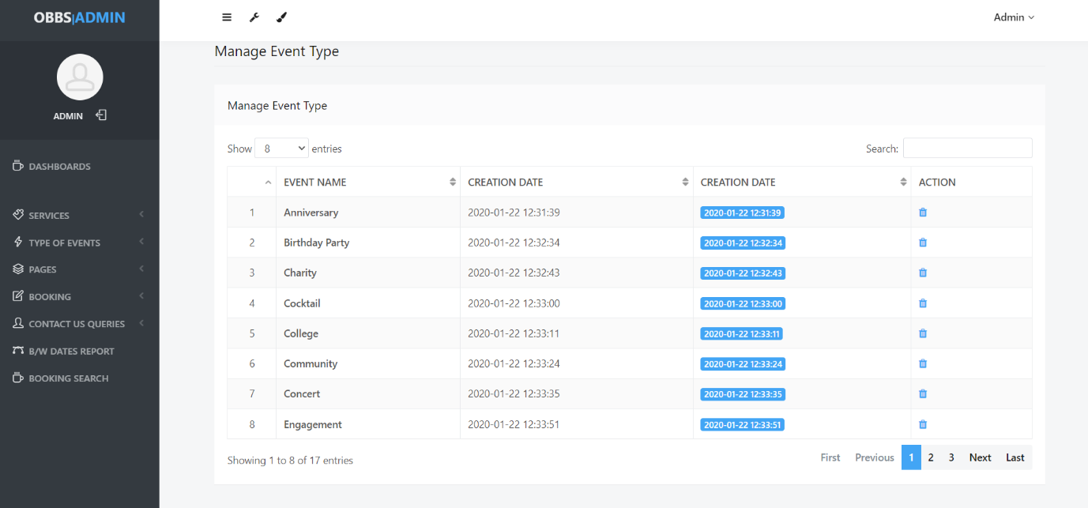

**About Us:**

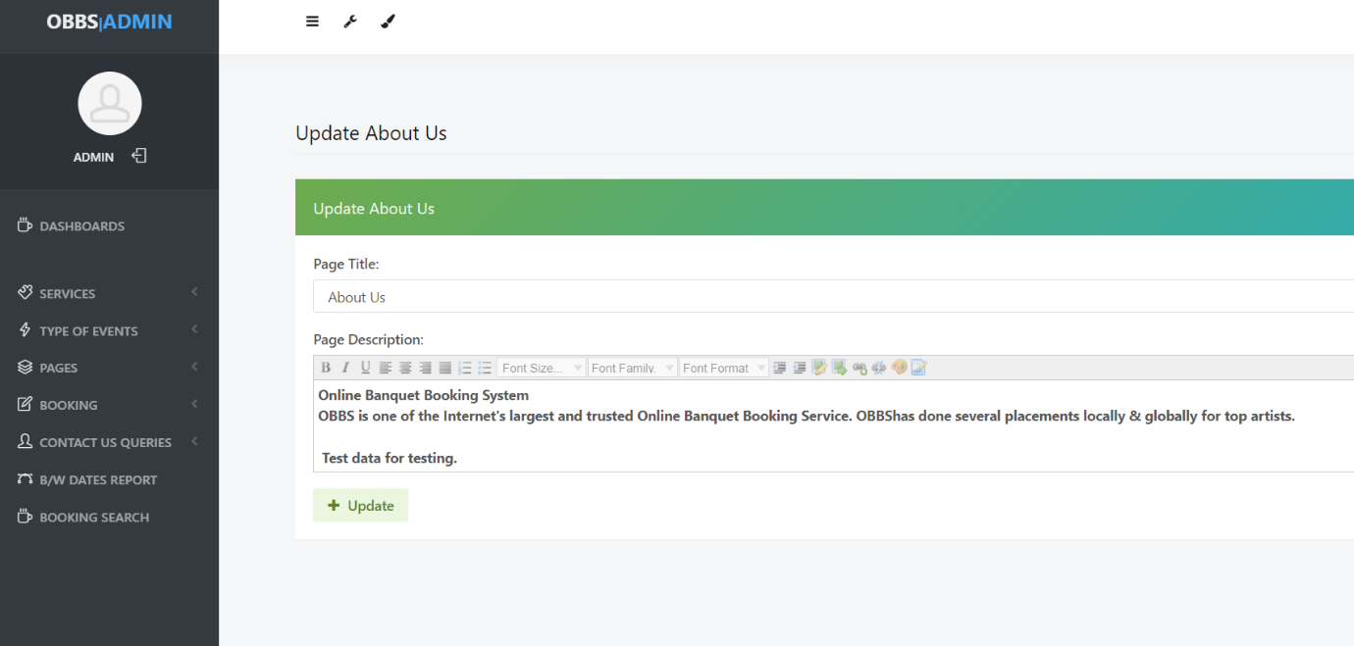

**13.**

**Testing**

nal end user requirements.

This is black box type of testing where external working of the software is evaluated with the help of requirement documents & it is totally based on user point of view. For this type of resting do not required knowledge of internal design or structure or code.

**TEST CASES**

**POSITIVE TESTING**

Testing Login Functionality with Valid

Registration Number and Password

|  |  |  |  |  |  |  |  |
| --- | --- | --- | --- | --- | --- | --- | --- |
| **Test Case Id** | **Test Title** | **Description** | **Input Data** | **Test Case Steps** | **Expected**  **Result** | **Actual**  **Result** | **Result** |
| 1. | Student login | Testing Login Functionality of student’s  Community  (home page)  For successful login | Valid Regno and Valid Password | 1.Open Login Page  2.Enter Valid Username  3.Enter Valid password  4.Click on SignIn | User logs on to Student’s community  (home page) | Logged on | Test case passed |

Testing Login Functionality with Valid Registration

Number and Incorrect Password

|  |  |  |  |  |  |  |  |
| --- | --- | --- | --- | --- | --- | --- | --- |
| **Test Case Id** | **Test Title** | **Description** | **Input Data** | **Test Case Steps** | **Expected**  **Result** | **Actual**  **Result** | **Result** |
| 2. | Student login  Test | Testing Login Functionality of student’s  Community  (home page)  For unsuccessful login with incorrect password | Valid Regno and Incorrect  Password | 1.Open Login Page  2.Enter Valid Username  3.Enter Valid password  4.Click on Sign In | Display Error  Incorrect password | Display error | Test case passed |

**NEGATIVE TESTING**

Testing Student’s community Login Functionality with

Registration number and Blank Password

|  |  |  |  |  |  |  |  |
| --- | --- | --- | --- | --- | --- | --- | --- |
| **Test Case Id** | **Test Title** | **Description** | **Input Data** | **Test Case Steps** | **Expected**  **Result** | **Actual**  **Result** | **Result** |
| 3. | Student login  Test | Testing Login Functionality of student’s  Community  (home page)  For unsuccessful login with blank password | Blank Reg no and blank password | 1.Open Login Page  2.Type blank email  Id in email id section | Display Error  Enter valid Id | Display error | Test case passed |

**Conclusion**

**CONCLUSION**

The project report entitled “Online Feedback System” has come to its conclusion. The new system has been developed with so much care that it is free of errors and at the same time efficient and less time consuming. System is robust. Also provision is provided for future developments in the system.

The “Online Feedback System” will be helpful for the students, employer as well as the Principal. Students are free to express their opinion on the course conduction and Principal has the opportunity to know the manner in which the course are conducted and perhaps advise the faculty in case the feedback is not satisfactory.

**Future**

**Enhancement**

**FUTURE ENHANCEMENT**

* Feedback can be converted to mobile application to increase usability.
* Provision for adding criteria for feedback can be given to admin.
* Feedback can be extended to non-teaching staff, Library staff, Lab staff infrastructure can be added.